Brandon Bond

SNHU

CS-340

2/26/25

This project was for a rescue training company, Grazioso Salvare. The goal of the project was to create a database where you can access all the rescue's information at once. This would be helpful for a company that has multiple locations and thousands of different animals.

There are a few required functionalities for this project. One functional requirement is the chart that displays the animals by breed, age, color, DOB, and more. Another functional requirement is the filters, this is where you can enter the information under the section you want to filter and find all animals of that type. A map with the location of the selected animal is another functional requirement for this project. Lastly, a pie chart displaying all breed types under the selected filter to show the percentage by the breed.

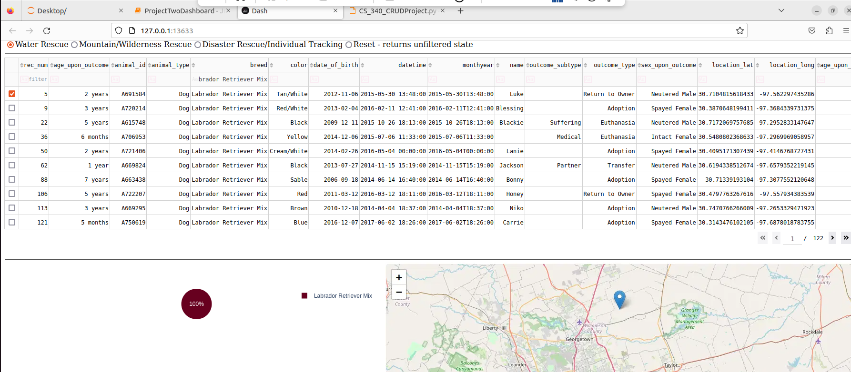

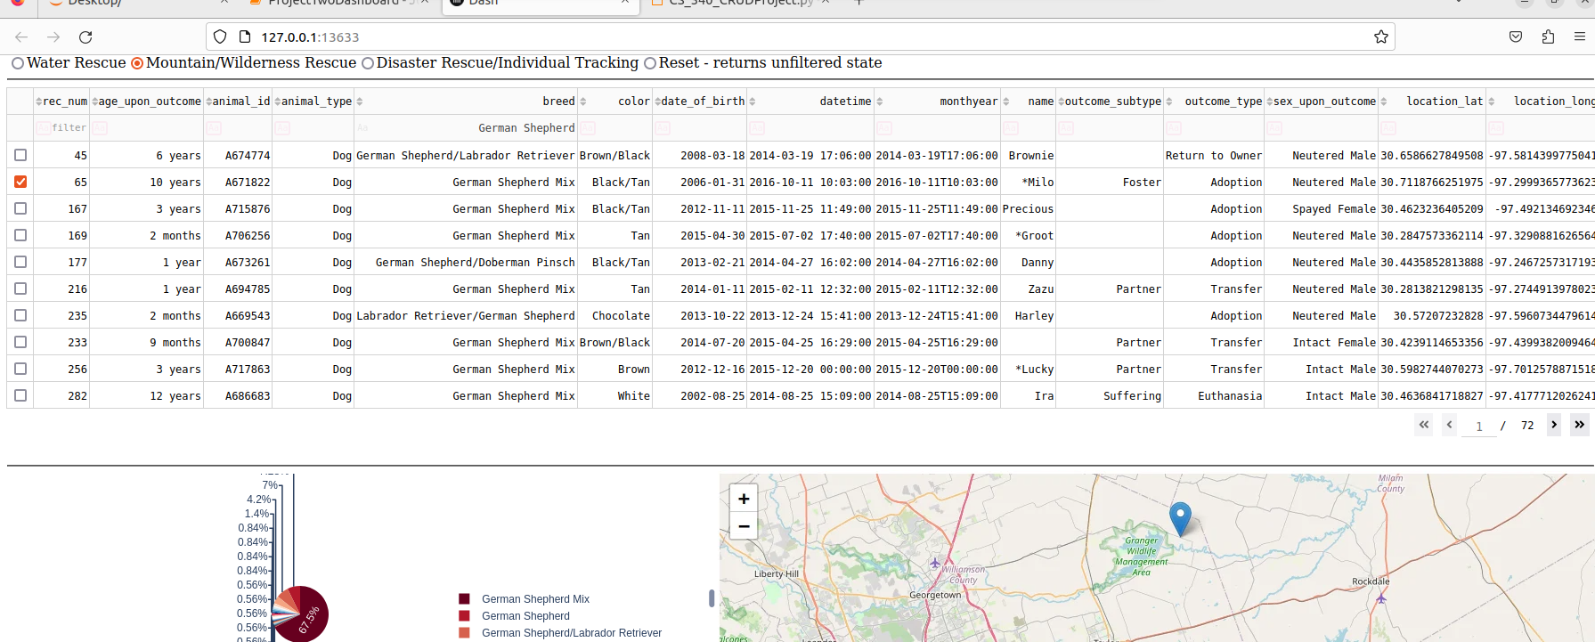

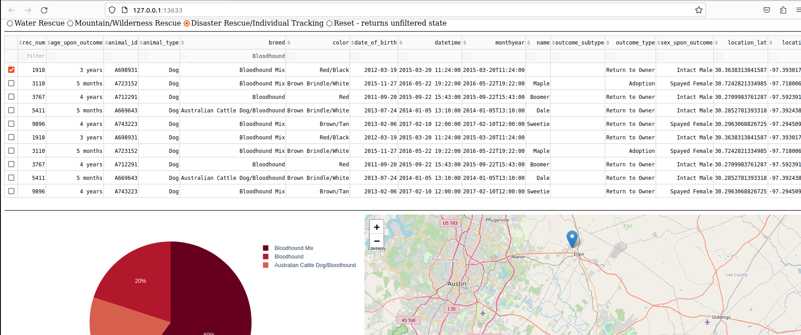

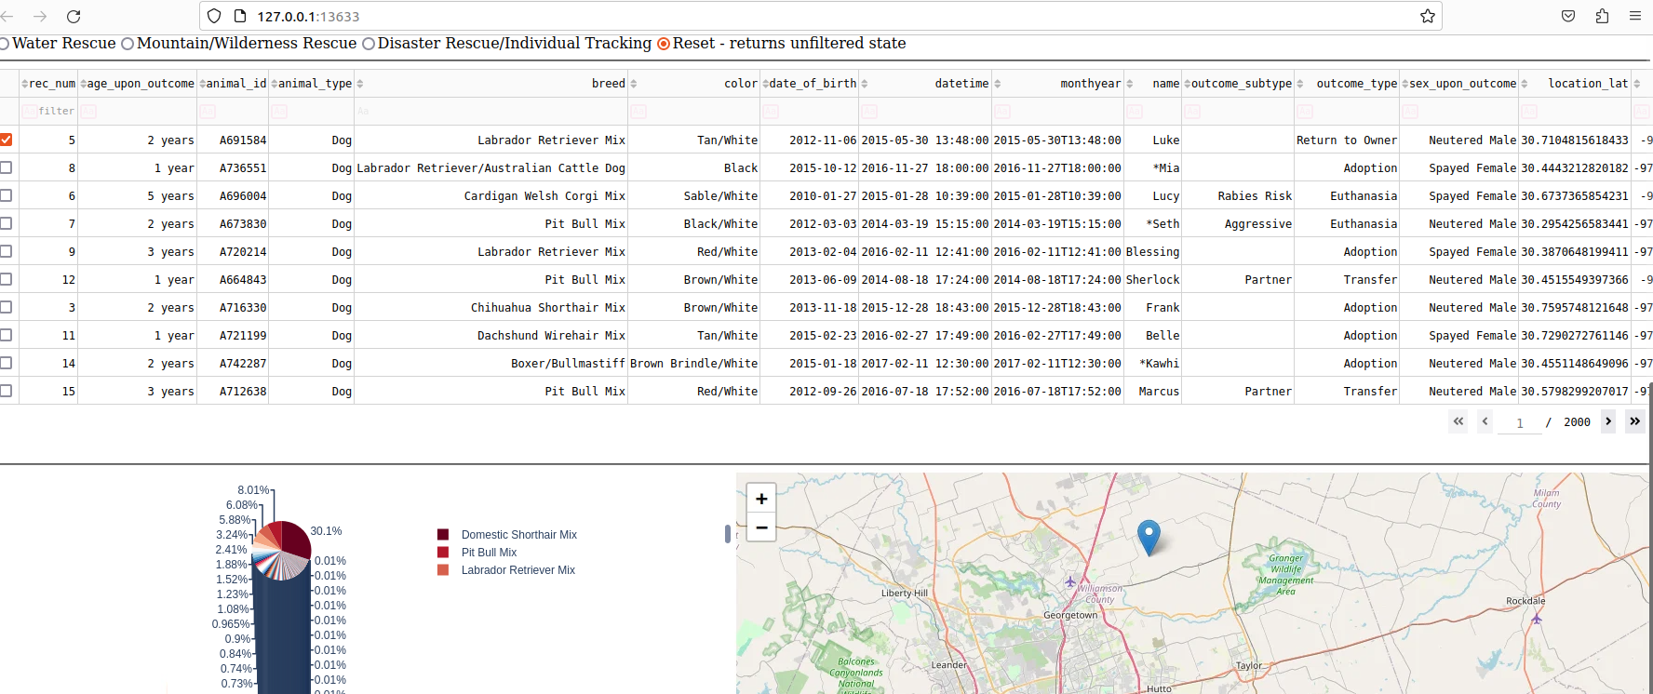

Requirements and tools to complete this project would include Linux, Jupyter Notebook, Mongo database, and the animal shelter csv file to access from the mongo db. MongoDB driver was the main model for development because it is a widely used driver that can offer a high-level API for interacting with the mongo database. Python is the interaction that is used with MongoDB, so python is the language used in the development process. The dashboard framework was built to show the database results and filters within the framework were entered to help search through the animal database. This was done by creating code that would allow interactions such as selecting a row, entering multiple filters, and selecting an overall rescue.